
Story

Date | 26 August 2026
Team ID | xxxxxx
Project Name | India’s agricultural crop production analysis (1997-2021)
Maximum Marks | 5 Marks

Observations:
1. Overall performance: India’s agricultural crop production analysis (1997-2021)
2. Crop Comparison: Rice has the largest cultivated area, flowed by wheat.
3. State comparison: Uttar Pradesh has the highest cultivated area among the displayed states.
4. Production Leaders: Karnataka is the leading state in agricultural production among the states displayed.
5. Seasonal pattern: Kharif season contributes the largest share of agricultural, Production followed by Rabi.
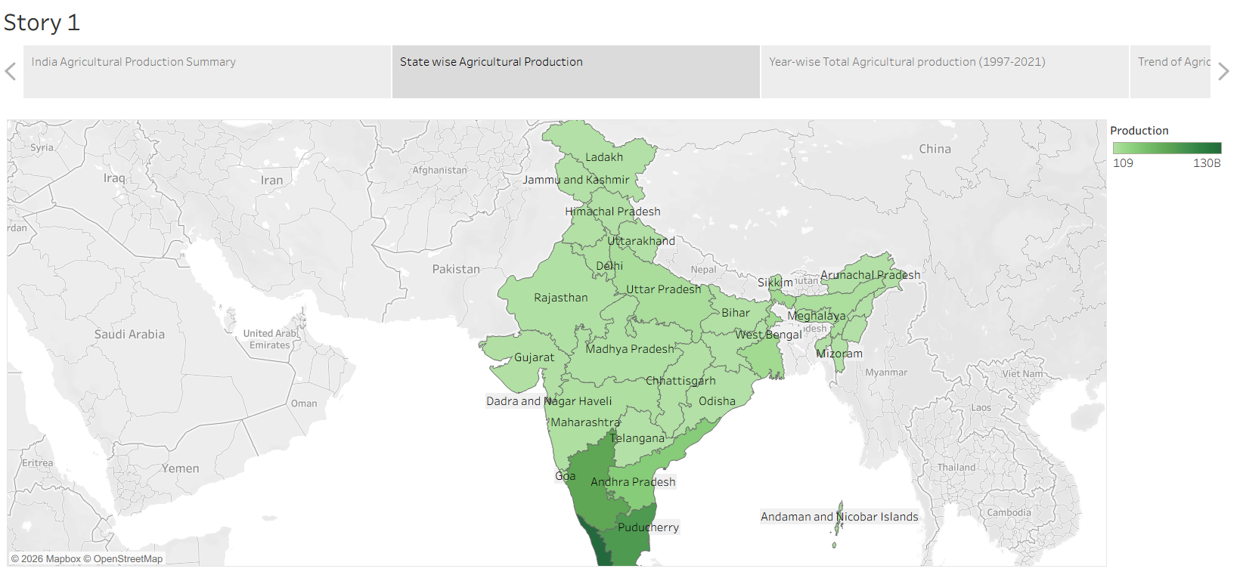

Activity 2:
Publish Story on Tableau Public and Paste Public link below
https://public.tableau.com/views/Book1_17878090788950/Story1?:language=en-US&:sid=&:redirect=auth&:display_count=n&:origin=viz_share_link

